Fig Tree Medical Practice - NEW PATIENT QUESTIONNAIRE - STRICTLY CONFIDENTIAL
This information will be recorded on your medical records and will help us to provide your medical care.

Full Name: |  |  | Previous Surname: |  | Date of birth:
Full Address: |  |  | Contact telephone numbers:  Home:  Mobile:  Work:  Emergency contact:  Do you consent to receiving text message reminders?  YES/NO
Name and address of your previous GP:
Sexual orientation: Which of the following best describes how you think of yourself:  Homosexual Straight  Gay or Lesbian Bisexual  In another way (please state): |  |  | Gender Identity and Trans Status Monitoring  - Woman (including trans women)  - Man (including trans man)  - Non-binary  - In another way (please state):  - Is your gender identity the same as the gender you were given at birth? YES/NO
Occupation: | Religion: |  | Next of Kin: |  | Marital Status:
Ethnicity: |  | Preferred spoken language: |  | Do you need an interpreter?  YES / NO
 |  |  | If yes, please provide details:
Do you have any current medical conditions? |  |  | YES / NO
Do you have any allergies? |  |  | YES / NO (If yes please list)
Are you a Carer for someone? |  |  | YES / NO
Are you a Foster Carer? |  |  | YES / NO
Do you have a Carer? |  |  | YES/NO (If yes, please provide a contact name and  number)
Are you a Military Service Veteran? |  |  | YES / NO
Females Only:  Are you pregnant? YES / NO If yes, when is your due date?  How many children do you have? |  |  | Names and date of birth of Children:
When was your last smear test?
Do you take any regular medicines?
YES / NO (If yes, please list all medicines and dosage or attach a copy of your repeat prescription)
Please tick your current smoking status:
Smoker Ex-smoker Never smoked

If you are a smoke – how many do you smoke each day?
Please answer all 3 questions:
How often do you have a drink containing alcohol?
N/A NEVER MONTHLY OR LESS 2-4 A MONTH 2-3 A WEEK 4+ WEEKLY

How many units do you drink on a typical day when you have a drink?
N/A 1-2 3-4 5-6 7-9 10+

How often have you had 6 or more units if female, or 8 or more if male, on a single occasion in the last year?
N/A Never Less than monthly Monthly Weekly Daily or almost daily

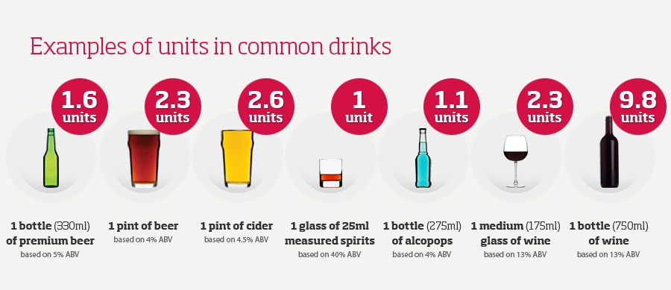
Additional information:
If you would like to register for online services, allowing you to make appointments and order your prescriptions online, please provide an email address:

Email:_________________________________________________________

Please make an appointment for a New Patient Health Check and please bring a urine sample along with you. Patients over the age of 40 may require a blood test.
The Practice will automatically create a summary care record for you, if you would like to find out more or opt out of this, please let the receptionist know.

